IoT based Smart Agriculture using Machine Learning

# KasaraSaiPratyushReddy

ComputerScienceandEngineeringInstituteofAeronautical EngineeringHyderabad,India

Y Mohana RoopaComputerScienceandEngineeringInstituteofAeronauticalEngineering

Hyderabad,India

[ymohanaroopa@gmail.com](mailto:ymohanaroopa@gmail.com)

# KovvadaRajeevLN

ComputerScienceandEngineeringComputerScienceandEngineeringInstituteofAeronauticalEngineering

Hyderabad,India

# NarraSaiNandan

ComputerScienceandEngineeringInstituteofAeronauticalEngineering

Hyderabad,India

***Abstract*—Agriculturebalancesbothfood requirementfor mankind and suppliesindispensableraw materials formanyindustries,anditisthemostsignificantandfundamentaloccupationinIndia.Theadvancementininventivefarmingtechniquesisgraduallyenhancing thecrop yield making it more profitable and reduce irrigationwastages. The proposed model is a smart irrigation systemwhichpredictsthewaterrequirementforacrop,usingmachinelearningalgorithm.Moisture,temperatureandhumidityarethethreemostessentialparameterstodetermine the quantity of water required in any agriculturefield. This system comprises of temperature, humidity andmoisture sensor, deployed in an agricultural field, sends datathrougha microprocessor, developing anIoT devicewithcloud. Decision tree algorithm, an efficient machine learningalgorithm is applied on the data sensed from the field in topredictresultsefficiently.Theresultsobtainedthroughdecisiontreealgorithm is sent through a mail alert to thefarmers,which helps in decision making regarding watersupplyinadvance.**

***Keywords—IrrigationSystem,IoT,SoilMoisture,Temperature,Humidity,DecisionTreeAlgorithm,Mailalert.***

1. INTRODUCTION

InternetofThings(IoT)isanadvancedtechnologyformonitoringandcontrollingdeviceanywhere in the world. It can connect devices with livingthings. Internet of Things is making a significant mark inmanyfields. Nowadays, the adaptive nature of IoT hastransformed, can be utilized by an ordinary user. Severalmethodologiesthat IoT has developed made man’s lifeeasierandcomfortablelikesmarteducation,cities, e-healthsectorandautomation[13].Apartfromman’scomforts, these methodologies should be implemented onbasicneedslikefood,whichcanbeachievedfromthe

agricultural fields. World Bank has estimated that morethan 50% food need to be produced before 2050 if thepopulation trend is at current rate. But the present climatechangeswouldn’tsupportsuchhuge crop production. Sofieldbasedsensors,drones,advancedtractorsandhydroponic farming may help future farmers to yield morecrop,atverylowprices.Therefore,thenecessityforelegant farming is growing exponentially. An enormousamount of the water withdrawals is occurring for farming.So, more precautions and discussions should be made inthefarmingarea.Indeed,agricultureprofitabilityisamajorpartofthearrangement.

Indiaisanationwhichiswell knownfor itsagriculture. In corresponding to growing yields, its watersystemneeds should be taken into notice. Harvestsrequirelegitimateirrigationsystem at proper time interimsforthem togrow well [11]. Agriculture isthe field wherethere is a high demand for the labour. The reason for thedecreaseinworkpowerwasverylowbecausethatadolescents were not enthusiastic about farming part andthey didn't discover a lot of opportunities. Subsequently,farmerswhodevotetheirtimestodevelopcropsinenormousregionsneeded tospendtheir entire dayoutsidetoguaranteethattheharvestsarebeingdevelopedappropriately. Farmers once in a while had great controlsoncropsandfurthermoreexperiencedincrediblemisfortunes because of unexpected and difficult climateconditions.

The work presented in this report was highly motivatedby the realization of future water scarcity that is going tocreateagreathavoc.AgricultureisthesignificantoccupationinIndiaandthesefieldsconsumeslargeamountofwater. Greater than80%of waterresourcesare

only used for the agriculture [7]. This continuous trendmayaffectthewaterresourcestobecompletelydiminished. Taking this into the consideration, a modelwasproposed to limit the water usage. For better landproductivity,implementingsmarttechnologyinagricultural practicesareneedtobefocused.

1. RELATEDWORK

In[1],theauthorshave proposedanirrigationsystemwhich assists to diminish water wastage and to mechanizethe water system structure for huge regions of cropland.The system evaluatesthe necessitiesof water inthe cropbasedonthebehaviorofatmospherictemperature,humidityandsoilmoisture.Theframeworkutilizesamachine learning technique and contrasts sensed valuesacquired from sensorsand a limit valuesthat has beengiven to the machine learning for further analysis. Afterthisprocedure,theMLalgorithmcrosscheckstheoutcomeacquiredwithwhether forecastandafterwardprovides a decision whether water supply should be doneor not [11]. The user gets an immediate notification on hismobilephoneandhe can decide to turn on the watersupply with a simple click. Also, the framework has a webapplication and is useful if at any point the user needs toseetheanalyticalsensorinformationandevaluate thechangesinsensorreadingsallthroughatimeframe.Moreover, the framework canbe aligned for various sortofplants,thatis,theclientisgivenalistofplant’sdecisions in his web application and mobile application[12]

. With this the farmer can pick the particular sort of plantthatisbeingcultivatedandgetanincreasinglyexactthreshold limit and in this manner a progressively preciseirrigationprediction. Inaddition, anSMS alertcanbecoordinated by chance there is no web access. With this,the client would be informing about the predictionsbymeans of a SMS and he can decide to turn on or off thewater supply to the crop by answering to the SMS that theuserreceived.

In[2], the authorshave expressedIoT asthe gatewaybetweenthethings.Theydiscussedtheimportanceofwateringanddevelopmentofroofingsystemfortheoutdoorcropfields,highlightingthesignificantcontributionof agriculturetowardsThai economy.Formore precise values, Kalman filtering techniques is usedto remove noisy data in sensed information. Mainly thesystem comprisesof soil moisturedata and other physicalfactorsretrieved from the sensors[10]. A decision treemodel is utilized to calculate the accurate timing to startwateringatparticularstandards.Besides,amobileapplication is developed so that farmer can know the fieldstatustimetotime.

In[3]theauthorshaveelaboratedandproposedanirrigationsystemusinginternetofthings,mainlyconsidering the wastage of water in the regions of SouthAlgeria.UsingWirelessSensorNetwork(WSN),IoTalongwithConstrainedApplicationProtocol (CoAP) asmartirrigationsystemwasdevelopedwhich can beeasily managed and tracked to make sure the water usagemoreeffectively.Thissystemiscorroboratedtobelow

cost and detailed and was importantly designed to managethewatersupplyingthroughinternet.

In [4], the authors have discussed an automated irrigationsystemusinganAndroidOperatingSystemsmartphone asa remote control. A soil moisture sensor sends a voltagesignal proportional and analyzedwitha constant thresholdnumber taken from different soil compositions. This datais sent to raspberry pi through HC05 module to a mobilephone. The resultsare shown on a user interface which isdeveloped to use smartphone as a remote control and tomanagetheirrigation system switching off or on. Thissystem is considered as a feasible one, therefore can beutilizedasareal-timeapplication.

In [5], the authors have introduced IoT in order to detectthephysicaldataandsendittotheuser.Theyalsohighlightedmethodologieswhichcanbeutilizedtoprovidesolution to different problemslike recognizingrodents, several risksto crops. IoT device is developedusingpythonscripts,whichcansendanotificationwithnohumaninterference.

In[6], theauthors have discussed the concepts of webservicesand IoT which has a great capacity in handlingthe huge data regarding the cultivation field by using theconceptof internetof thingsand other web services. ThiscombinationofcloudservicesandIoThasadvancedquickly and also contributed a lot to develop numeroussmart solutions for the problems in agricultural fields aswell as problems faced by the farmers, very productively[14].

In [8],the authors proposed an intelligent water systemwhich will go about as a benefit by optimizing the watersystem while showingthe issue of water deficiency byinitiating optimal utilization of water through modernizedIoT based procedure. The brilliant irrigation module can bealteredonparticularneedofdifferentyields.Thisinformation can be put away on the server [9]. In view oftheharvestchosenbythe farmer onthe mobile apps,information would be retrieved from the servers and theframeworkwouldmodifyitselfaccordingly, bringingaboutefficientirrigationsystemandexpandedyields.

1. PROPOSEDMETHOD

SupervisedMachineLearningalgorithms,apreviously labeled data for which the answers are alreadyknownisgiventothemachinetolearnthepatternsinvolved in it. It analyzes the different kinds of data, theanswersforeachdifferentproblem andgetsa patterninvolved in it. This phase is called training the data. Thelarger the data, the more accurate the results will be. Thenextstageinvolvedinsupervisedmachinelearningistesting the data. In this phase, a problem is given to themachineto solve, the machine having known the patternof solving the problem and the possible answers, gives themostsuitableanswerforit.Asmentionedearlier theaccuracyof the result will be based on the size of the data,the algorithms used in the data and various other factorslikenoiseandoutliersinthedatagivenasinputfortraining. Learning and prediction are the two major stepsforanyclassification.Themodelisdevelopedusingthe

feed training data in the learning step. The model shouldpredicttheresultsbasedonthetrainingdataintheprediction step. To perceive and interpret, decision treealgorithm,anefficientclassificationalgorithm canbeused.

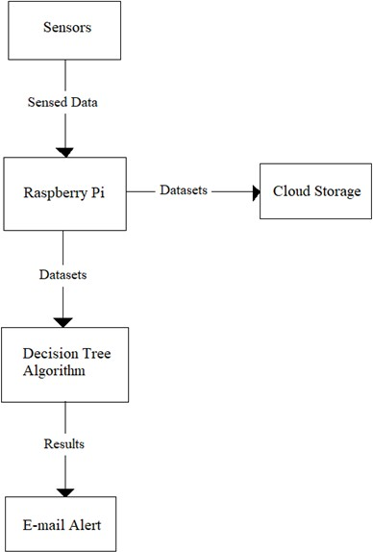

Figure1.DataFlowDiagram

Thedataflow diagram representsthe direction of flow ofdata regarding a system. It provides inputs and output ofthe entitiespresent inthe system. The data flow model fortheproposedsystemisasinFigure1.

1. *Algorithm*

* The decision tree algorithm isone of the efficient andsimplealgorithmamongthesupervisedlearningfamilyofalgorithms.
* The decision tree algorithm is used to solve severalregressionandclassificationproblems, unlike fromtheotheralgorithmsinsupervisedlearning.
* The main objective of decision tree algorithm is totrain the model which can predict the value or class oftarget variable bygeneratingclear and uncomplicateddecisionrulesderivedfrom thepreviousdatai.e.,trainingdata.
* To predict a class label of a record, it is required tostartfrom thefirstnodethatisrootnodeof thedecisiontree.Therecord’sattributeshouldbevalidatedwiththevaluesofeachandeveryrootattribute.
* Based on the validations, a path containing branchesare followed with the matching value and jump to thesucceedingnodeasshowninfigure2.

Terminologyindecisiontreesare:

* + Root node: It is a starting node or a parent node whichisdividedintotwoormoreanalogoussets.
  + Leafnode:Thesearelowerlevelnodesofthetree

which doesn’tsplitfurther.

* + Decisionnode:Itisasub-nodesplittingintomoresub-nodes.
  + Splitting:Itisa processof splitting a node into morenodes.
  + Pruning:removingofsub-nodes,reverseprocess ofsplitting.
  + Sub-tree/Branch: It is a part of an entire decision tree.Childnode:Thenodeevolvedfromparentnodebysplitting

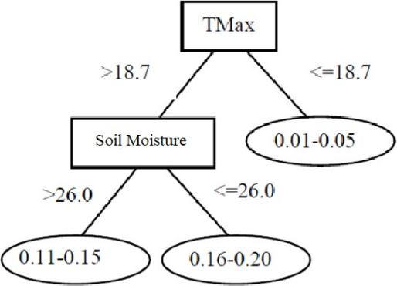

Figure 2.SampleDecisionTree

1. *Architecture*

The maincomponents of the proposed system architecturearetemparature,soilmoisture,humiditysensorsandraspberrypi.

* RaspberryPi playsa central role inthe system byproviding storage to the datasets and hosting a webserver.
* The DHT11 an Soil moisture sensor are deployed inthe field and are connected to raspberry pi as showninFigure3.
* Thedatasensedthrough these sensorsare sent toraspberrypiandarestoredandproccessedinit.
* Decision tree algorithm is applied on the datasets inordertopredicttheaccurateresults.
* Theresultissenttothefarmer throughan emailregardingthewatersupply.
* All data sent from the sensorsto the raspberry pi arestoredinaclouddatabaseforfutureuse.

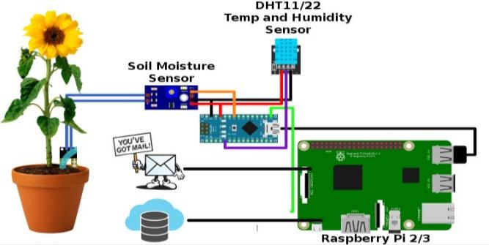

Figure3.ArchitectureDiagram

1. *Dataset*

Datasets containing values of temperature, humidity andsoil moisture are loaded into the decision tree algorithm.These datasetscontain values of different scenarios in thefieldsinordertotrainthemodelaccurately.ThetemperatureisinCelsius,humidityandsoilmoistureare

represented inpercentages. Sampledatasets are as show inTable1.

Table1.SampleDataset

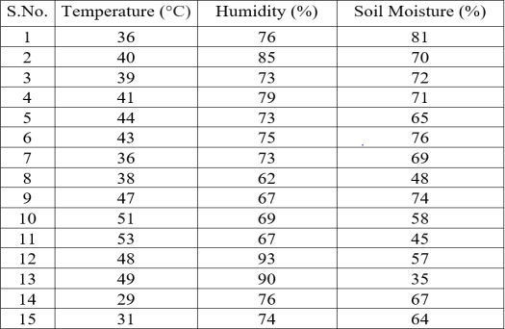

1. RESULTS

Thesampleoutputasshowninfigure4 contains thevalues of temperature in both Centigrade and Fahrenheit,humidity, water presence, and prints as well as sends an e-mailalerttofarmer.

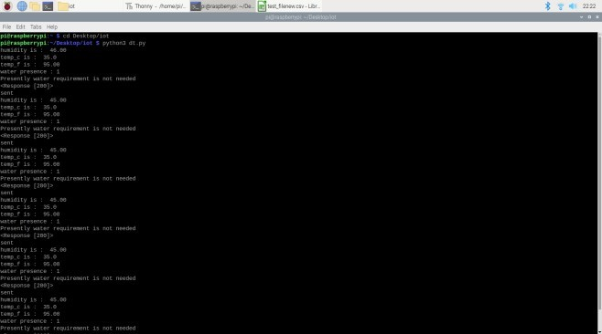

Figure4.SampleOutput

Afterapplyingdecisiontreealgorithmonthesenseddatasets, an output containing the decision to water thecrop ismade. This output containing decision is sent tothe usersor famers through an Electronic mail (E-mail)using Simplemailtransferprotocol.

ThetwotypeofdecisionsarenamedasYesandNo.

1. If the algorithm predictsthe result as yes, then analertissent tofarmerasshowninFigure5.
2. Ifthealgorithmpredictstheresultasno,thenalertis

senttofarmerasshowninFigure6.

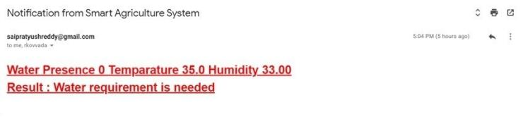

Figure5.E-mailalertforWaterrequirement

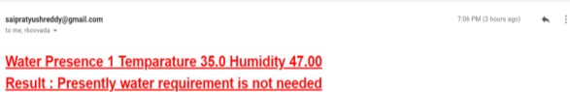

Figure6.E-mailalertforNoWaterrequirement

The values of temperature, humidity and water presencearealsostoredinacloudstorageforfuturereferences.

1. CONCLUSION

The work presentedinthis paper was highly motivated bytherealizationof future water scarcity that isgoing tocreateagreathavoc.AgricultureisthesignificantoccupationinIndiaandthesefieldsconsumeslargeamount ofwater.

Greaterthan80%ofwaterresourcesareonlyusedforthe

agriculture. Thiscontinuoustrend may affect the waterresources to be completely diminished. Taking this intoconsideration, a model wasproposed to limit the waterusage. For better land productivity, implementing smarttechnologyinagriculturalpracticesareneedto befocused.

The system wasprogrammed to be trainedfrom the givendataset using all the sensed data from the soil moisture,temperatureandhumiditysensors.Byapplyingthedecisiontree learningalgorithm, whichisfrom the familyof supervisedmachinelearningalgorithms, on the realtimedata itsprocesses and generates an output yes/no andsends the decision to the farmer through an email. Usingthisdecision, a farmer can decide himself to water thecrop only when required, avoiding the wastage of wateruse.

REFERENCES

* 1. Dishay Kissoon, Hinouccha Deerpaul and Avinash Mungur, “ ASmartIrrigation and Monitoring System”, *The InternationalJournalofComputerApplications*,vol.163,No.8,Apr.2017.
  2. P.Narayut, P. Sasimanee, C.-I. Anupong, P. Phond and A.Khajonpong, “ A Control System in an IntelligentFarming byusing Arduino Technology”, Student Project Conference (ICT -ISPC),2016FifthICTInternational,27-28May2016.
  3. K. Benahmed, A. Douli, A. Bouzekri, M. Chabane and T.Benahmed, “ Smart Irrigation Using Internet of Things”, FourthInternational Conference on Future Generation CommunicationTechnology(FGCT),29-31Jul.2015.
  4. A. N. Arvindanand D. Kartheeka, “Experimentalinvestigationof remote control via Android smartphone ofArduino-basedautomatedirrigationsystemusingmoisturesensor”,3rdInternational Conference on Electrical Energy Systems (ICEES),17-19Mar.2016.
  5. T. Baranwal, N. and P. K. Pateriya, “ Development of IoT basedSmart Security and Monitoring Devices for Agriculture”, 6thInternationalConference-CloudSystemandBigDataEngineering(Confluence),14-15Jan.2016.
  6. M. K. Gayatri, J. Jayasakthi and G.S.Anandha Mala, “ProvidingSmart Agriculture Solutions to Farmers for better yielding usingIoT”, IEEE Technological Innovation in ICT for Agriculture andRuralDevelopment(TIAR),10-12Jul.2015.
  7. Openweathermap.com,[2012-2016],Availablefrom:<http://openweathermap.org/api>
  8. KiranShinde,JerrinAndrei,AmeyOke,“ WebBasedRecommendation System for Farmers”, *International Journal onRecent and Innovation Trends in Computing and Communication*2,Volume:3,Mar.2014.
  9. Y.MohanaRoopa,et.al,”ASurveyofFogComputing:Fundamental, Architecture, Applications and Challenges” ,IEEEInternational conference on IoT in Social, Mobile, analytics andCloudISMAC-19,December 12-14,2019.ISBN:978-1-7281-4364-4,PageNo:498-502.